An Initial Definition of the "Post-Perception" Movement
Prepared by: Ibrahim Shalabi
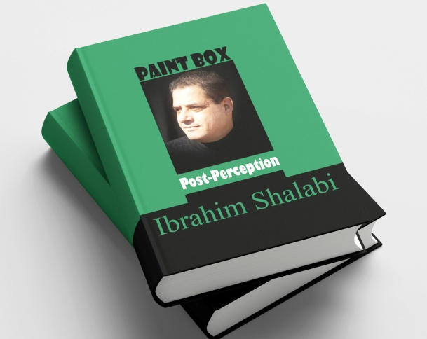
Conceptual Artist and Founder of the Post-Perception Movement

I. Theoretical Introduction
"Post-Perception" is an intellectual and artistic endeavor to re-interrogate the relationship between the artwork and human consciousness, particularly in an era where perception has become burdened by simulations, representations, and visual technologies that repeatedly and intricately reshape reality.
If classical art focused on representation, modern art on experimentation, and conceptual art on the priority of the idea over form, then "Post-Perception" emerges to transcend all these levels. It seeks to expose the fragility of the senses, highlight their limitations, and open a new horizon for aesthetic thought that treats perception itself as an object for deconstruction.
This movement does not merely generate artworks; it proposes a philosophical and aesthetic stance that calls the perceptual experience into question:
- How do we perceive?
- What is excluded from our senses?
- What are the limits of visual and linguistic representation in containing truth?

II. Philosophical and Artistic Foundations
Post-Perception is built upon several pillars, formulated as follows:
- Idea Before Representation: Artworks are defined by the philosophical inquiry they pose.
- Perception as the Subject of Art: The artwork serves as a tool to reveal the inadequacies and confusions of perception.
- Sensory Fragility: Exposure of sensory gaps and the susceptibility of the senses to manipulation and artificiality.
- The Interactive Dimension: The recipient is an integral part of the experience, lured into discovering their inability to fully represent reality.
- Critical Transcendence: Breaking free from the captivity of previous schools (Realism, Surrealism, Conceptualism) by critiquing them from within rather than denying them.

III. The Founding Manifesto of the Post-Perception Movement
Through this text, we announce the establishment of the "Post-Perception" movement as an open artistic and intellectual movement, seeking to redefine the position of art in an age of intensifying images and fragmented truths.
- We consider perception itself as the raw material of art.
- We put the senses to the test of doubt, revealing their vulnerability to deception and refraction.
- We reject the reduction of art to a visual commodity or a superficial decoration of reality.
- We affirm that every artwork is a cognitive experience as much as it is an aesthetic one.
- We believe the future of art lies in transcending the boundaries of the visible and the audible, moving toward interrogating the gaps, the voids, and the unperceived.
Thus, "Post-Perception" is proposed as an open horizon for dialogue and experimentation. It invites artists, researchers, and the public to reconsider the simplest human act: To see, and to perceive.

